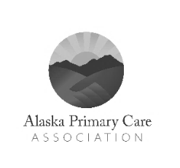
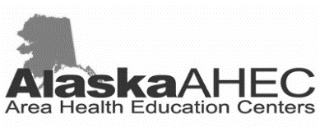
Each self-paced training module includes:
- Real patient stories
- Model provider-patient interactions
- Interactive patient exercises with feedback

3 or 6 hours of complimentary CME and CNE credits available
(see reverse for details)
Suicide is a silent epidemic and public health crisis
In the US, suicide is a more common cause of death than breast cancer, prostate cancer, or traffic fatalities.

In 2014 the rate of Alaska Native males that died by suicide was nearly four times the national average.

All Patients Safe provides the necessary tools to medical providers to understand their role in suicide prevention by teaching them how to:
- Integrate screening and assessment tools into their practice
- Educate patients on keeping homes safe
- Refer patients to additional resources
- Follow up with those at risk for suicide

Medical professionals can make an enormous impact
With questions or to register, please email: northwest@mhttcnetwork.org

Learn more about the Northwest MHTTC at:
www.mhttcnetwork.org/northwest
All Patients Safe
Suicide Prevention Training for
Alaskan Medical Professionals

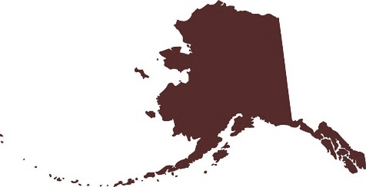
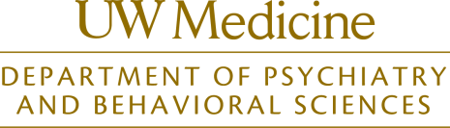

of all people
who die by
suicide see a primary care provider in the
month prior to
their death.
50%%%

Alaska has the
highest
suicide rate in
the United States.
2nd

Suicide is the cause of death
for Alaskans aged
10-64 years.
#1

Distributed in partnership with:

Continuing Education Statements

Continuing Nursing Education (UWCNE)

Professionals who wish to receive a contact hour certificate must 1) complete all course requirements and 2) register online after completing the activity. You will be able to print your own certificate online and have access to your records online for at least six years.

A certificate for 3 or 6 contact hours will be awarded, depending on which course is completed.

Nurses:
- Continuing Nursing Education at the University of Washington School of Nursing (UWCNE) is accredited as a provider of continuing nursing education by the American Nurses Credentialing Center’s Commission on Accreditation.
- UWCNE is approved as a clock hour provider by the Washington State Board of Education.
- Provider approved by the California Board of Registered Nursing, Provider #7218.
Psychologists:
UWCNE qualifies as a Washington State CE program sponsor under Washington Administrative Code (WAC) 246-924-240.

Respiratory Therapists:
UWCNE qualifies as a Washington State CE program sponsor under Washington Administrative Code (WAC) 246-928-442.

Social Workers and Counselors:
UWCNE qualifies as a Washington State CE program sponsor under WAC 246-809-610.

Other Disciplines:
A certificate will be awarded for use in documenting completion of this offering.

Continuing Medical Education

The University of Washington School of Medicine is accredited by the Accreditation Council for Continuing Medical education to provide continuing medical education for physicians.

The University of Washington School of Medicine designates this enduring material for a maximum of 6.0 AMA PRA Category 1 Credits™. Physicians should claim only the credit commensurate with the extent of their participation in the activity.

