Identifying Core Values

WORKSHEET
Starting Points:
- The “Core Values Pyramid”© represents characteristics of the best YOU that you can become.
- Not others’ expectations or desires for who you are, but your own.
- Start with ONLY the first five blocks on the bottom and leave the rest blank.

STEPS
- Identify a characteristic or descriptor (one in each of the bottom five blocks on the next slide) that describes you as the person that you would like to more fully develop or that you aspire to become.
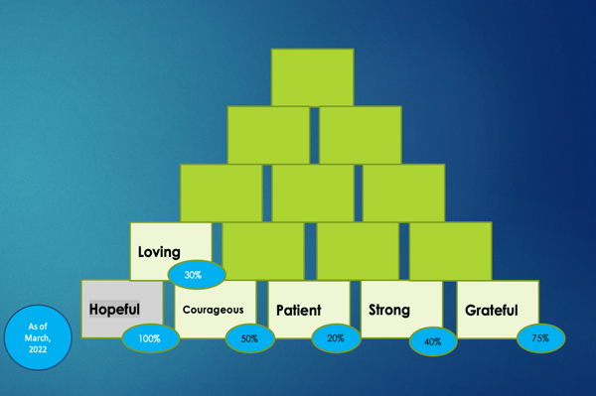
- Evaluate the percentage to which you feel as if you are completely embodying each value, as of today’s date, in the small blue circle next to that value. Remember: to be at 100% you need to embody this value in ALL aspects of your life and in all the various roles you play. (Friend, leader, parent, sibling, etc Sample here:

- Pick one or two that you would like to focus on for development.
- On another piece of paper, or the back of same- Define how embodiment of those value would look in your daily life. See example here:

VALUE | ROLE | CHALLENGE / OBSTACLE | OPPORTUNITY
EXAMPLES: Patient
 | Parent | Tiredness | Slow down when disciplining
 | Clinician | Frustration | Look for connections in their story
Strong
 | Self - Physical | Time to exercise during day | Walks in evening with kids
 | Self- Mental | Too much work | Boundaries for time on computer at night
FILL IN BELOW  VALUE | ROLE | CHALLENGE / OBSTACLE | OPPORTUNITY

