Establish-Maintain-Restore Guide
Establish-Maintain-Restore (EMR) is a research-based system for building health student-teacher relationships. It is built upon research investigating general healthy relationship qualities and practices, with adaptions to meet the unique dynamic between teachers and students. It has been investigated within schools and has been determined to be quite effective when implemented with fidelity. In addition, it has even demonstrated success with teachers building relationships with students who are culturally and linguistically diverse compared to themselves.
Since EMR is a whole system, it would be too overwhelming to provide the full protocol and all its accompanying resources. If you are interested in receiving the full training and support, we recommend contacting its developer Dr. Clayton Cook (current email: crcook@umn.edu) and his colleagues for more information.
However, its practices can still be of use. This activity is meant to be a surface-level, initial effort guide to implementing EMR as an individual by providing an overview of the practices from the protocol. In other words, it is an ongoing activity. We highly encourage you to also review the PLC protocol and implement EMR as an ongoing practice with your PLC team.

Section 1: Knowing the Stages
EMR divides the student-teacher relationship into three stages: an Establishment stage, a Maintain stage that is an ongoing process, and Restore stage when the relationship is damaged and needs repaired to return to the Maintain stage.
Each stage is accompanied by very specific practices that can be implemented in person or remotely. See the figure on the next page.
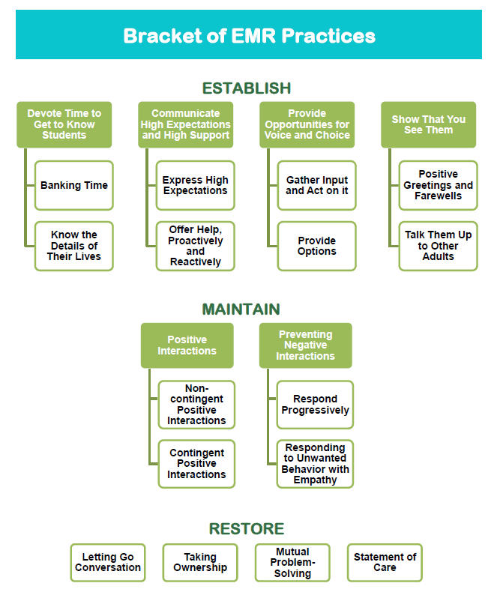

Before learning the practices themselves, we need to identify which students are in each stage relative to ourselves. In other words, some students might be in the Establish stage for your but have already moved onto the Maintain stage with another educator. That is okay and normal. EMR will help you set reasonable goals for building those relationships one-at-a-time.
Section 2: Identifying the Stages
The first stage of any relationship involves intentional efforts to get to know the other person. The goal is for each person to feel a sense of belonging, connection, trust, understanding, and acceptance of the other. The relationship remains in the Establish stage until these qualities have a solid basis. For many of us, these qualities are easy to establish with some individuals and more difficult with others. We all have our own temperaments, personality quirks, and preferences, and these can be accounted for when building any relationship.
The second stage of a relationship is an ongoing process of balancing each other’s needs and maintaining the above qualities once established. It, too, is intentional. For students and teachers, that means ongoing efforts to assess the relationship, providing positive interactions, and validating each other. This helps Maintain that connection.
The last stage is when qualities of a healthy relationship diminish either from a lack of interaction, communication breakdowns, or a specific critical event. It is characterized by a lack of any one of the qualities first established—most often, trust. Although both the Establish and Restore stages have instances of where some healthy quality is lacking, the Restore stage is different in that those qualities at one point existed.
Now that you know what each stage is characterized by, use the student roster on the next page to begin identifying where you think your relationships are at. We do not need to be accurate; just give your best guess. Fill out all your student names and put a mark at the stage you think the relationship is at. If you need more space, make a copy!
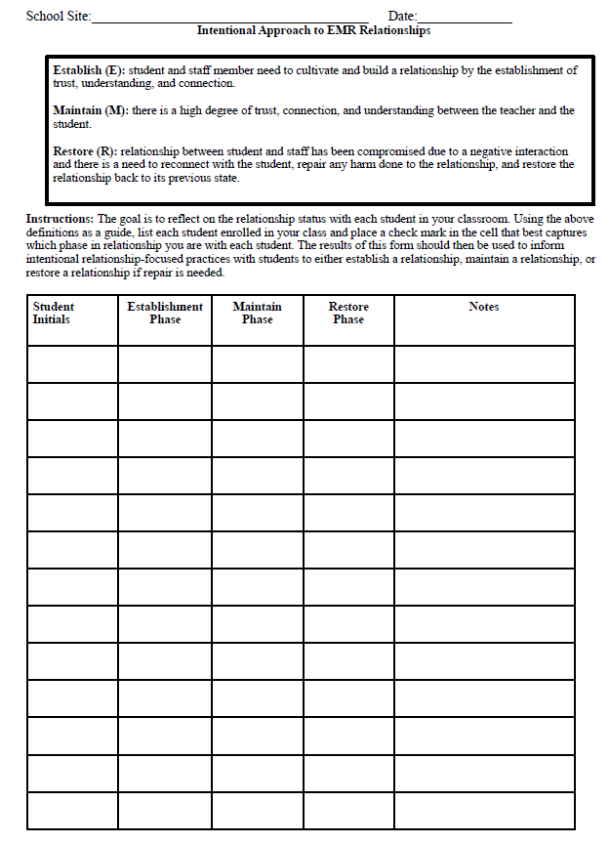

Next, we need to figure out if there are any barriers that are preventing some relationships from being Established or Restored. Often, those barriers include some emotional reaction, a bias, a past event, lack of time, etc.
Use the Equity/Triage tree tool on the next page. To use this tool:
- Write down the names of students you connect with easily on the lowest apples. These are your “low hanging fruit”; they take little effort to connect with.
- Write down names of students you have struggled to Establish with or need to Restore. Put them in the middle and top apples. These are the students for you that are difficult.
- Draw a line that roughly divides the apples into those 3 sections so it is easier to see.
- Adopt the mindset of a scientist and look for patterns. What is it about your low-hanging students that requires less intentional effort to Establish and Maintain with? What about the middle and top students? In what ways might race/ethnicity, gender identity, sexual orientation, socioeconomic status, spiritual beliefs, parental background, and even your own personal history with the student explain their position?
- Use the PLC form (at the end of this guide) to set a goal for building those relationships. Make sure to use the table at the end that helps you walk through those barriers.

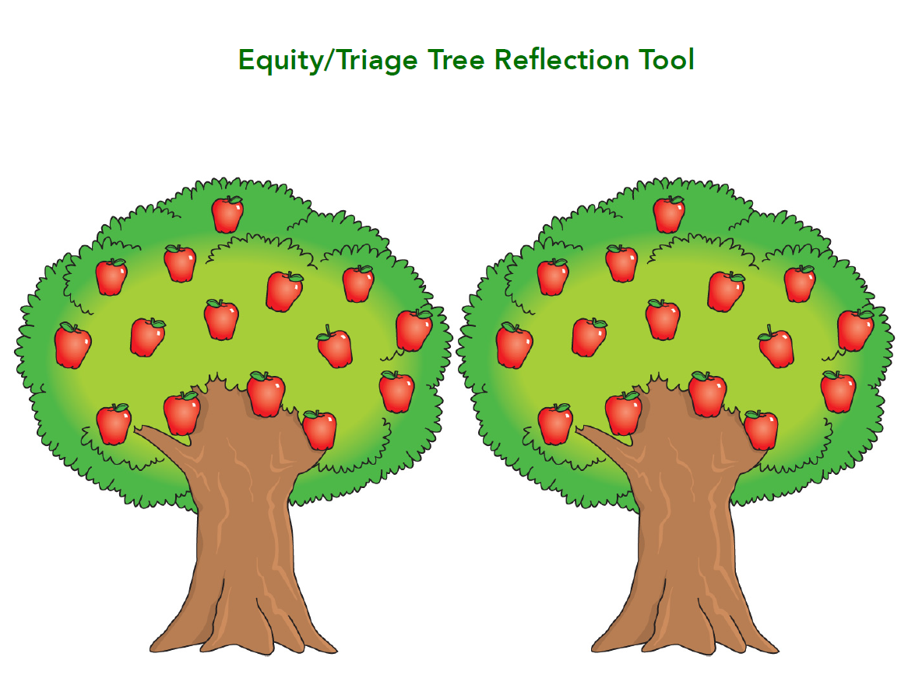
Section 3: Learning the Practices
Each stage has research-supported strategies for helping move the relationship through that stage. These practices are easy-to-implement, adaptable, and effective. There are also subtle nuances when considering personal and cultural barriers. Below we provide a brief review of select strategies (4 Establish, 2 Maintain, 2 Restore). As we mentioned earlier, if you want more support in mastering these strategies and incorporating them into a whole-team/whole-school effort, please consider reaching out to the EMR developers for assistance.

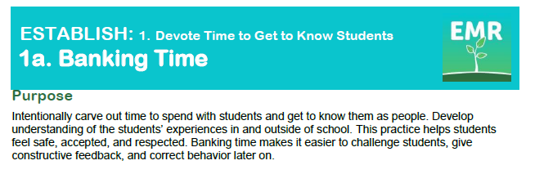
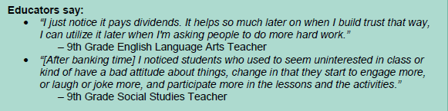
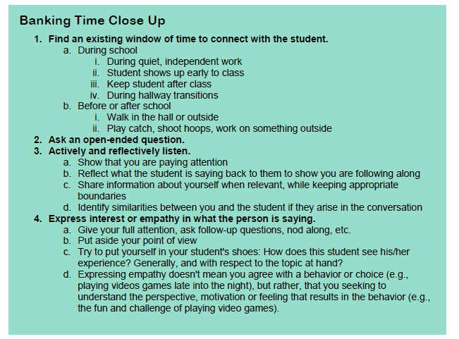

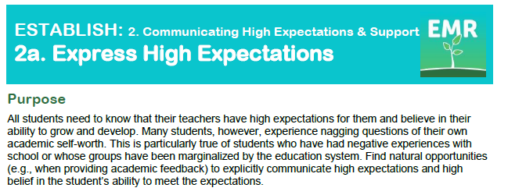
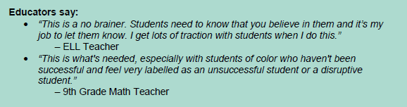
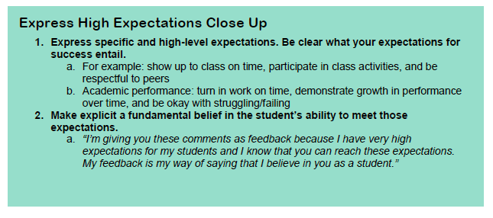

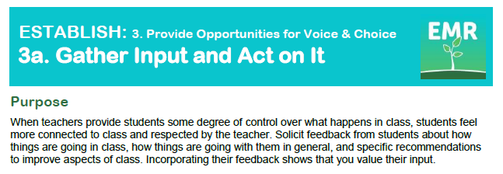
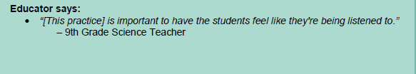
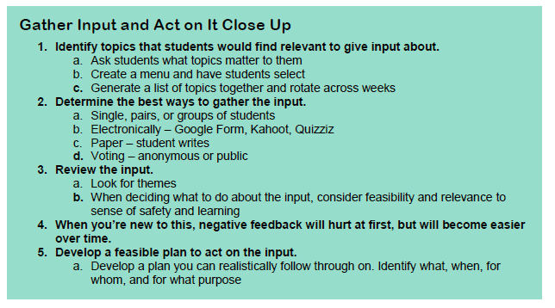

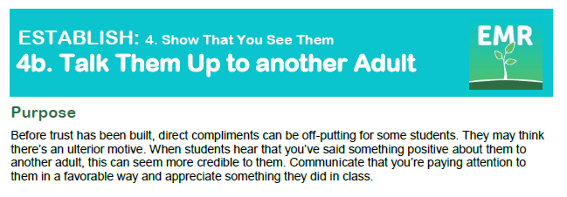
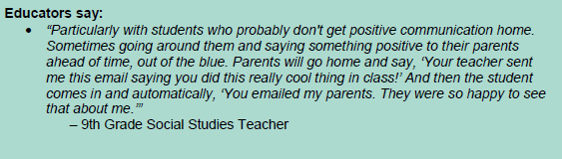
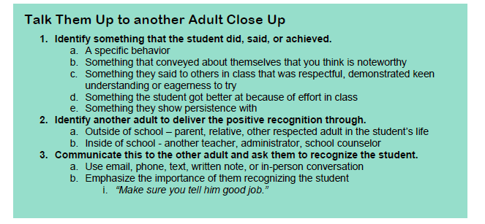

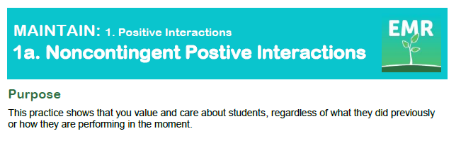
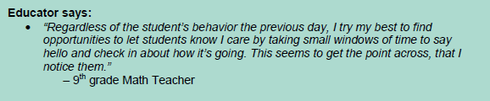
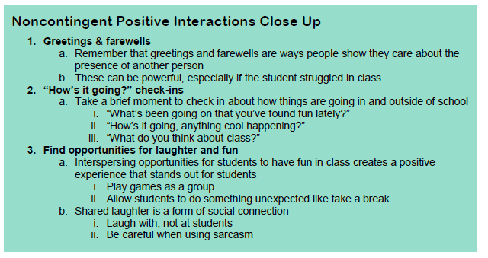

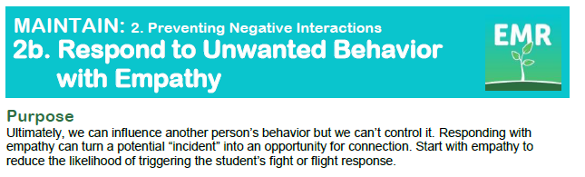
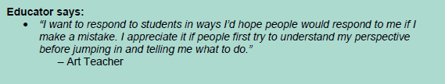
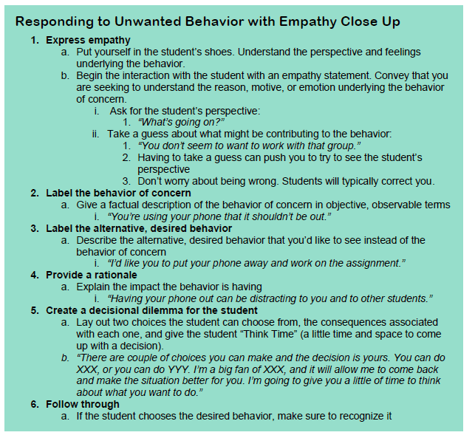
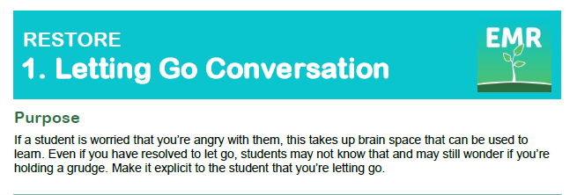
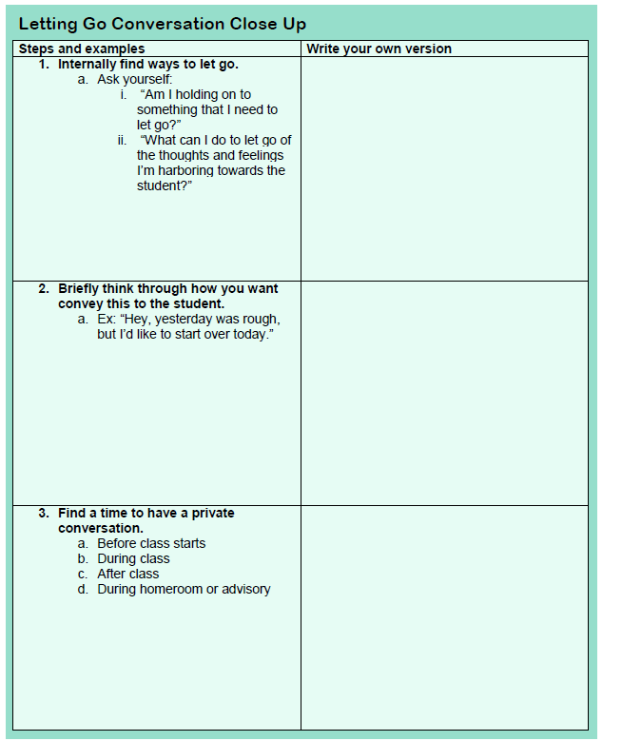
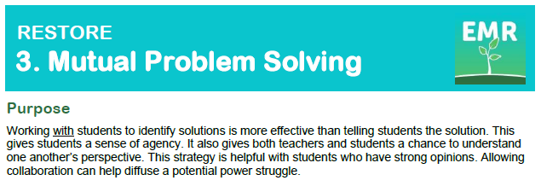
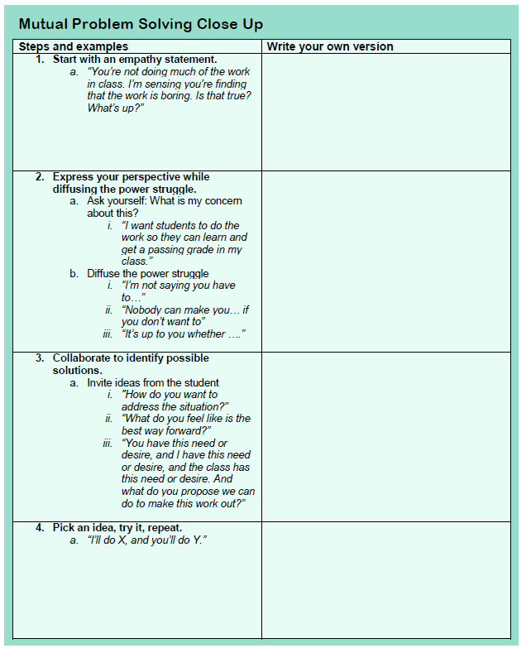
Section 4: Implement as a Team
EMR can be successful when implemented individually. It is more successful, though, as part of a regular school-wide practice. It allows educators to support one another, learn from one another about how to connect with specific students, breakdown particular EMR strategies and share strategies for implementing it more successfully, and facilitates ongoing goal-setting and progress monitoring. This practice really begins with the PLC.
With the permission of the EMR developers, we have included the entire monthly PLC EMR protocol for you to use. It can be implemented in person or remotely. After the protocol are some suggestions for maintaining student relationships when engaged in remote/distance learning practices.

