Urge Surfing
An urge is a strong desire or craving to act impulsively and out of habit. An urge occurs right before a behavior and is experienced as an intense physical and emotional experience. Urges get triggered by an event, thought, feeling, memory, or image and pull us towards automatic ways of responding. Urges can feel like waves, they rise in intensity and tug and pull us towards using old behaviors that may provide us a temporary relief, but often lead to negative consequences in the long run. Rather than struggling and fighting an urge we can ride it by staying present and mindful, noticing the moment it peaks and the moment it crashes.
Urges are temporary. Therefore, you don’t have to act on them for them to change and morph. Whenever you feel the impulse or have the nagging thought, bring your attention to your breathing and bodily sensations and stay curious and present with your present moment experiences. Urge surfing is a mindfulness technique used to get through an urge without acting on destructive impulses. When you notice an urge, rather than fighting against it, imagine you are on a surfboard riding with it. Notice the shifting sensations, how they rise and fall, come and go.

Part 1: Getting practice with a simple meditation practice
Urge surfing builds upon our base mindfulness skill by not only being aware of our thoughts and emotions but by increasing our ability to experience discomfort, boredom, apathy, etc.
To practice this skill, we are going to sit still for three minutes. It is likely that an urge will arise to itch or shift in your chair. Resist this urge and practice surfing it instead by practicing be mindful and still. Remember, urge surfing is just like riding a wave. Urges come and go, and we don't need to act on them. The urge can and will go. Play the video below for a demonstration.
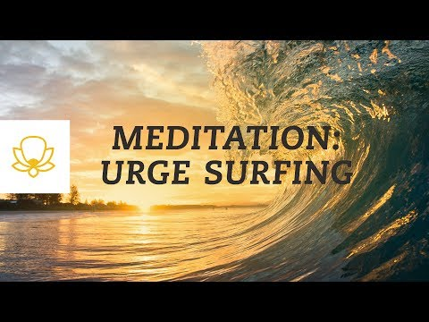

Part 2: Increasing the challenge
When it comes to mindfulness, there is no “winning.” There is no level of mindfulness that one might consider “expert.” But there is a skill to it—a skill that can be improved when things get challenging. Practicing urge surfing while listening to a video in a safe environment is one thing; doing it in “real life” is entirely different.
So, we need to increase the challenge in order to get the skill to transfer from one activity to another. Try some of these increasingly challenging exercises below:
- Re-watch the video, sitting where you are, but put something under your legs that creates a strong sensation (e.g., something with a pointy edge)
- Grab an ice pack and hold it with your bare hands as long as you can
- Hold your breath for as long as you can. Do this multiple times.
- Stare into your partner’s/teammate’s eyes without saying anything for 3-5 minutes

