Paced Breathing: Box Breathing
Paced breathing is slow, deep, breathing into your belly. With normal breathing, you take about 12 to 14 breaths a minute. By comparison, with paced breathing you take only 5 to 7 breaths a minute. That translates to one breath every 10-12 seconds. With paced breathing, you generally want your exhale to be longer than your inhale. Paced breathing slows the activity in your central nervous system and decreases your emotional reactivity by triggering a relaxation response.

Part 1: Box breathing
There are many ways to do paced breathing, as long as the general principle of slowing down your breath and finding space between inhale and exhale is upheld. Here is a video from a licensed therapist that describes why regular practice of paced breathing is beneficial, and also demonstrates the box/square breathing strategy.
Box breathing slows the breath down to about 3.5 breaths a minute. And it divides the inhale/exhale cycle into four even segments. Use this video to practice this most foundational strategy.
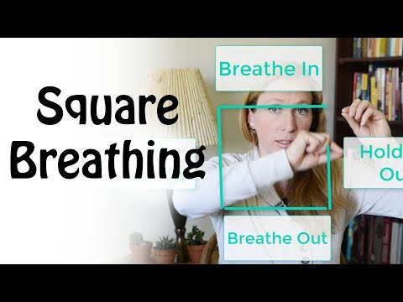

Part 2: Expanding to other practices (4-7-8)
Now that you have practiced box breathing, incorporate this into your daily life. You can also change up the technique to get closer to the ideal of a rapid inhale and longer exhale. You might, for example, try breathing in for 2 seconds and get a full breath, before holding and then exhaling for 4 seconds each.
Or you can try the 4-7-8 method.
Breath in for 4 seconds.
Hold your breath for 7 seconds.
Exhale making a “whoosh” sound for 8 seconds.
Pause and repeat 4x.
Why practice this change? Because in our moments of stress, we might notice first our breathing is more rapid and shallow. And this helps practice how to slow that breath down and make it deeper.

